FLASK WITH IBM DB2 MAIN

from turtle import st

from flask import Flask, render_template, request, redirect, url_for, session

from markupsafe import escape

import ibm_db

conn = ibm_db.connect("DATABASE=<databasename>;HOSTNAME=<your hostname>;PORT=<portnumber>;SECURITY=SSL;SSLServerCertificate=DigiCertGlobalRootCA.crt; UID=<username>;PWD=<password>",'','')

app = Flask(__name__)

@app.route('/')

def home():

return render_template('home.html')

@app.route('/addstudent')

def new_student():

return render_template('add_student.html')

@app.route('/addrec',methods = ['POST', 'GET'])

def addrec():

if request.method == 'POST':

name = request.form['name']

address = request.form['address']

city = request.form['city']

pin = request.form['pin']

sql = "SELECT * FROM students WHERE name =?"

stmt = ibm_db.prepare(conn, sql)

ibm_db.bind_param(stmt,1,name)

ibm_db.execute(stmt)

account = ibm_db.fetch_assoc(stmt)

if account:

return render_template('list.html', msg="You are already a member, please login using your details")

else:

insert_sql = "INSERT INTO students VALUES (?,?,?,?)"

prep_stmt = ibm_db.prepare(conn, insert_sql)

ibm_db.bind_param(prep_stmt, 1, name)

ibm_db.bind_param(prep_stmt, 2, address)

ibm_db.bind_param(prep_stmt, 3, city)

ibm_db.bind_param(prep_stmt, 4, pin)

ibm_db.execute(prep_stmt)

return render_template('home.html', msg="Student Data saved successfuly..")

@app.route('/list')

def list():

students = []

sql = "SELECT * FROM Students"

stmt = ibm_db.exec_immediate(conn, sql)

dictionary = ibm_db.fetch_both(stmt)

while dictionary != False:

# print ("The Name is : ", dictionary)

students.append(dictionary)

dictionary = ibm_db.fetch_both(stmt)

if students:

return render_template("list.html", students = students)

@app.route('/delete/<name>')

def delete(name):

sql = f"SELECT * FROM Students WHERE name='{escape(name)}'"

print(sql)

stmt = ibm_db.exec_immediate(conn, sql)

student = ibm_db.fetch_row(stmt)

print ("The Name is : ", student)

if student:

sql = f"DELETE FROM Students WHERE name='{escape(name)}'"

print(sql)

stmt = ibm_db.exec_immediate(conn, sql)

students = []

sql = "SELECT * FROM Students"

stmt = ibm_db.exec_immediate(conn, sql)

dictionary = ibm_db.fetch_both(stmt)

while dictionary != False:

students.append(dictionary)

dictionary = ibm_db.fetch_both(stmt)

if students:

return render_template("list.html", students = students, msg="Delete successfully")

# # while student != False:

# # print ("The Name is : ", student)

# print(student)

return "success..."

# @app.route('/posts/edit/<int:id>', methods=['GET', 'POST']) # def edit(id):

# post = BlogPost.query.get_or_404(id)

# if request.method == 'POST':

# post.title = request.form['title']

# post.author = request.form['author']

# post.content = request.form['content']

# db.session.commit()

# return redirect('/posts')

# else:

# return render_template('edit.html', post=post)

● ADD_STUDENT .HTML

<a href="/">HOME</a>

<a href="/addstudent">Add New Student</a>

<a href="/list">List Student</a>

<hr>

<form action = "{{ url_for('addrec') }}" method = "POST">

<h3>Student Information</h3>

Name<br>

<input type = "text" name="name" /></br>

Address<br>

<textarea name="address" ></textarea><br>

City<br>

<input type = "text" name="city" /><br>

PINCODE<br>

<input type = "text" name="pin" /><br><br>

<input type = "submit" value = "submit" /><br>

</form>

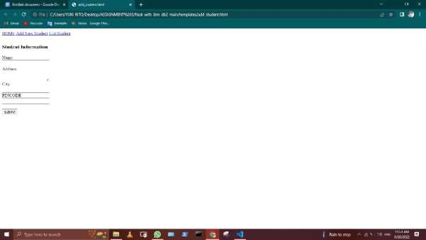

● HOME.HTML

●

● <a href="/">HOME</a>

● <a href="/addstudent">Add New Student</a>

● <a href="/list">List Student</a>

● <hr>

●

● {{YUKI RITO}}

●

● <h1>Welcome to Student DB APP</h1>

IMAGE:

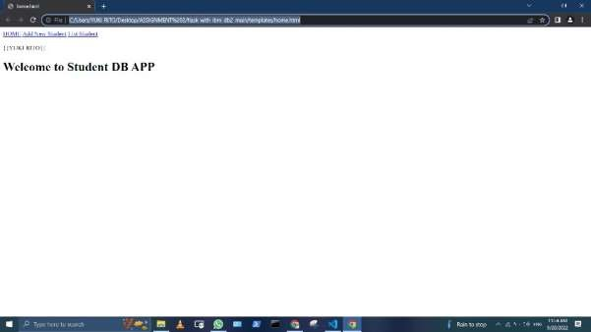

● List.html

<!doctype html>

<html>

<body>

<a href="/">HOME</a>

<a href="/addstudent">Add New Student</a>

<a href="/list">List Student</a>

<br><hr>

{DATA ENTRY}

<table border = 1>

<thead>

<td>Name</td>

<td>Address</td>

<td>city</td>

<td>Pincode</td>

<td></td>

</thead>

<tr>

<td>YUKI RITO</td>

<td>ANAICUT</td>

<td>VELLORE</td>

<td>632101</td>

<td><a href="/delete/{{row['NAME']}}">Delete</a></td>

</tr>

</table>

</body>

</html>

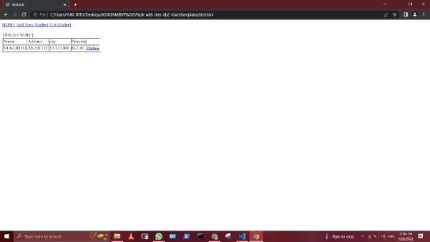

 RESULT.html

<!doctype html>

<html>

<body>

<h2><a href = "\">Back to home page</a></h2>

</body>

</html>

